CSE 231 Spring 2017

**Programming Project #1**

**Assignment Overview**

This assignment involves coding and testing of a program that uses Python arithmetic.

The basic design of your first program that in this class prompts for input, performs arithmetic on that information and then displays the results.

This assignment is worth 15 points (1.5% of course grade), and must be completed before 11:59 PM on Monday, January 16th. (Projects are typically due on Mondays.)

**Background**

This programming project will use the input and print functions along with some simple mathematics for conversion. The important part of the project is to learn the skills needed to access the class web site to download a project description, create a new program in Python and finally to hand it in.

**Program Specifications**

Conversions are useful both in science and daily life. Here we examine some obscure, but useful conversions as well as some silly ones.

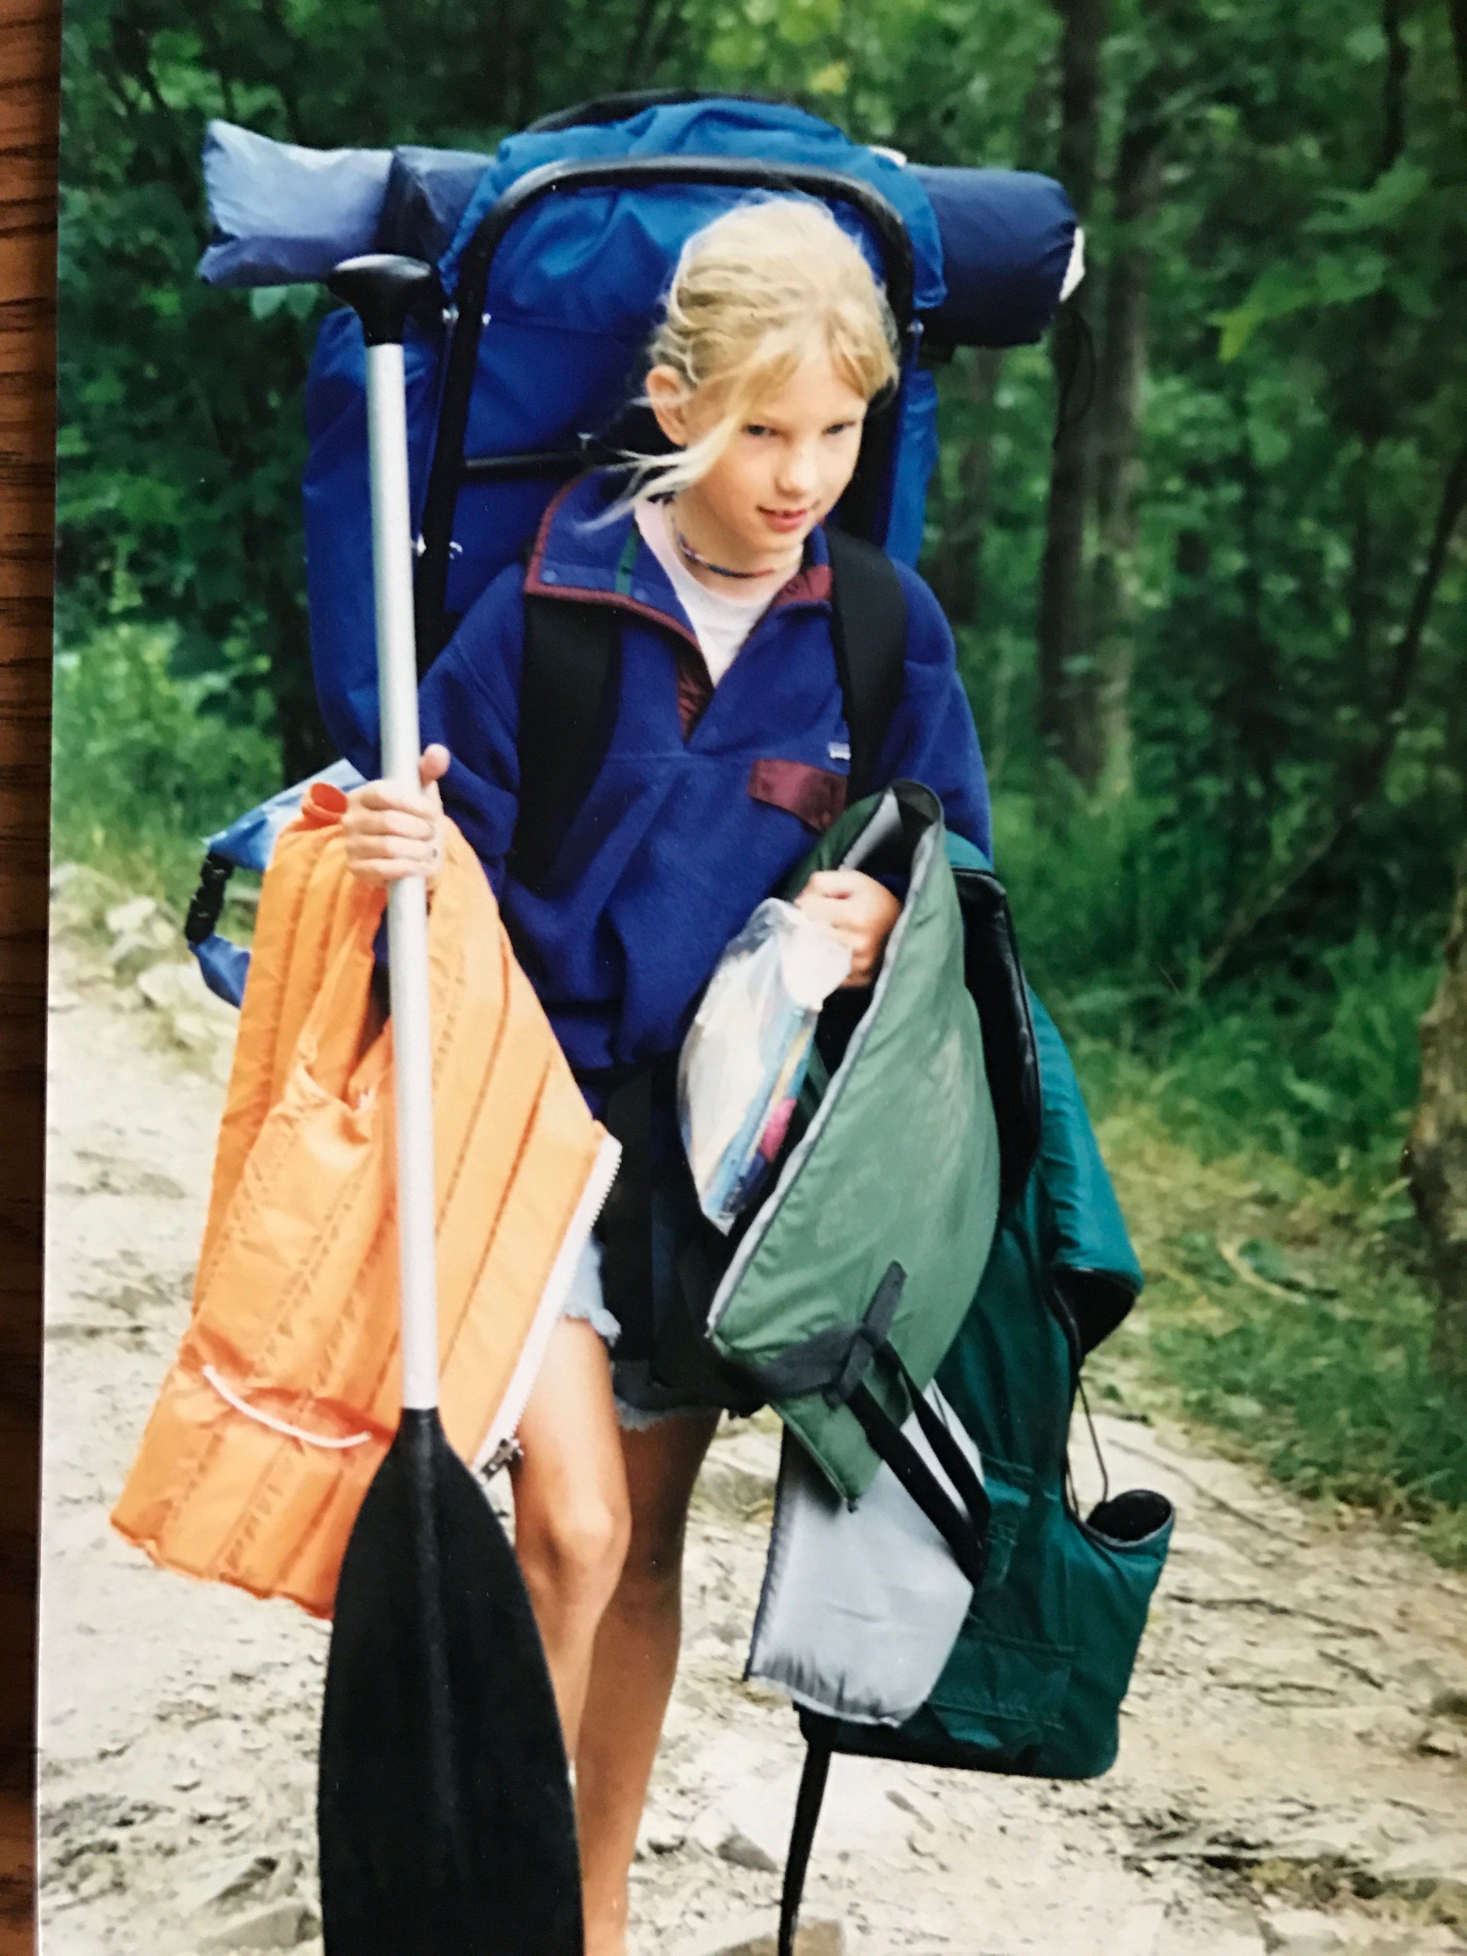

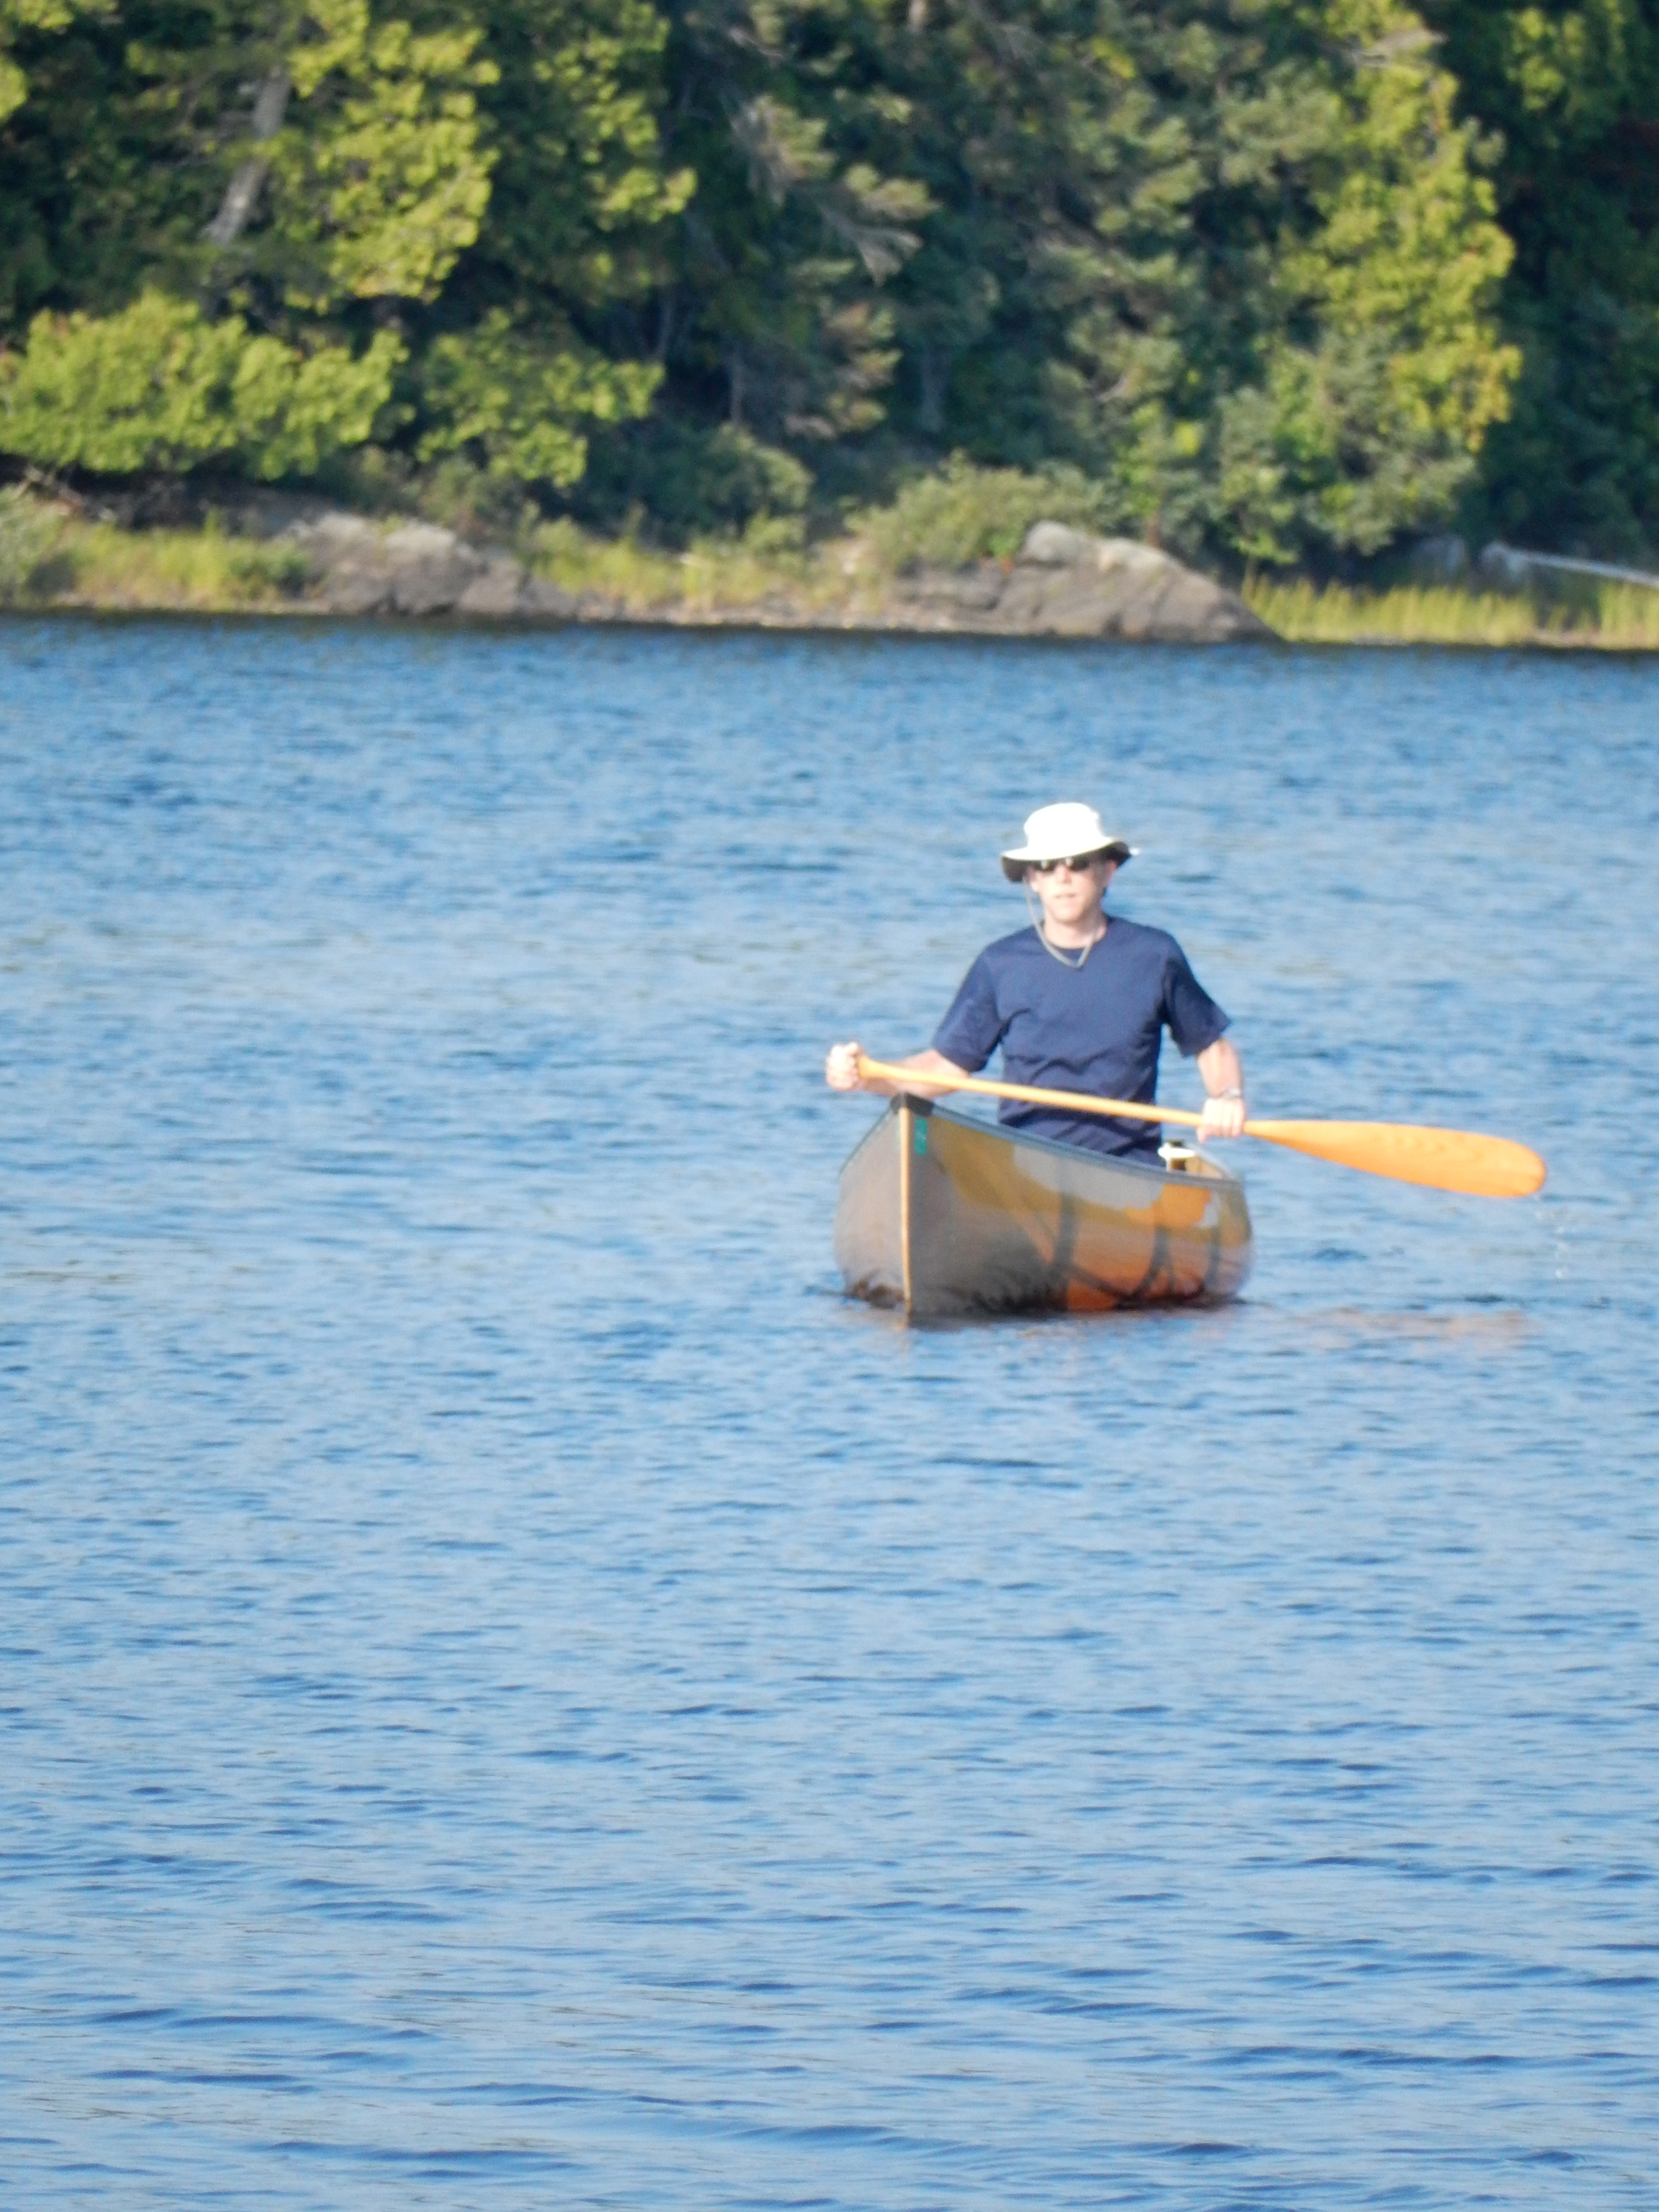If you canoe in the [Boundary Waters Canoe Area](https://en.wikipedia.org/wiki/Boundary_Waters_Canoe_Area_Wilderness) you portage (carry) your canoe and gear between lakes as you wander deeper into the wilderness (left image is of Dr. Enbody canoeing; right image is daughter portaging). BWCA maps label distances on portages in [rods](https://en.wikipedia.org/wiki/Rod_(unit)), an old unit of measurement that is 5.0292 meters, which is approximately the length of a canoe so it is a useful measurement in the wilderness.

Here is a piece of a BWCA map showing portages between lakes (black lines) labeled in **rods** (red triangles are campsites).



Your program will prompt the user for a floating-point value representing a distance in rods. You will reprint that value along with that value converted to the following values. The most important value is the time to walk the portage.

* meters
* feet
* miles
* [furlongs](https://en.wikipedia.org/wiki/Furlong)
* the time in minutes to walk that distance

You can find these measures on the web, but so everyone is using the same conversions:

* 1 rod = 5.0292 meters
* 1 furlong = 40 rods
* 1 mile = 1609.34 meters
* 1 foot = 0.3048 meters
* average walking speed is 3.1 miles per hour

**Deliverables**

The deliverable for this assignment is the following file:

proj01.py -- your source code solution

Be sure to use the specified file name and to submit it for grading via the [**handin**](https://secure.cse.msu.edu/handin/) **system** before the project deadline

**Assignment Notes:**

1. To clarify the project specifications, sample output is appended to the end of this document.
2. Items 1-6 of the [Coding Standard](http://www.cse.msu.edu/~cse231/Online/General/coding.standard.html) will be enforced for this project.
3. The input function is used to accept a response from the user. The function accepts a string (a sequence of characters between quotes) as a prompt to display to the user. It then waits until the user types a response (terminated by the user touching the Enter key). Finally, the function returns the user’s response as a string.  
     
   If the user’s response is supposed to be processed as a numeric value, the returned string must be converted into a number. When working with floating point values, a string is converted into a floating point number using the float function. The function accepts a string as its argument and returns the floating point number which the string represents. A typical interaction would be something like:  
     
   num_str = input( "Please enter a number: " )  
   num_float = float( num_str )
4. The print function is used to display any combination of variables, values and strings in the output window. Each item to be displayed must be separated from another item by a comma. All the items will be displayed together, followed by a new line. For example:  
     
   print( num_int, " times two is ", num_int*2 )  
     
   Three items will be displayed when the print function is called: the value of the variable num_int, the string " times two is ", and the result of the calculation.  
     
   Assuming that the value of the variable num_int is 26, then the output will be:  
     
   26 times two is 52
5. The file named number_input.py in the project directory contains a program which illustrates the use of some standard library functions.

**Getting Started**

* *Solve the problem using pencil and paper first.* You cannot write a program until you have figured out how to solve the problem. This first step can be done collaboratively with another student. However, once the discussion turns to Python specifics and the subsequent writing of Python, you must work on your own.
* Use Anaconda Spyder to create a new program. Use the required file name (proj01.py).
* Write a simple version of the program, e.g. input the rods and print rods. Run the program and track down any errors.
* Use the **handin** system to turn in the first version of your program.
* Cycle through the steps to incrementally develop your program:
  + Edit your program to add new capabilities.
  + Run the program and fix any errors.
* Use the **handin** system to submit your final version.

**Sample Interaction**

First are two samples with 1 rod and 10 rods so the numbers are easy to check with pencil and paper.



Next is a test using a distance from the map: 444 rods



Scoring Rubric

If you correctly run the three sample tests, you will automatically get 10 of the 15 points. Here is the scoring rubric for this assignment.

Computer Project #1 Scoring Summary

General Requirements

__0__ (3 pts) Coding standard

Source code format

Source code header and descriptive comments

Mnemonic identifiers (variables and symbolic constants)

Program Implementation

__0__ (10 pts) Correctly calculates distances

2 pts each: meters, feet, miles, furlongs, time

__0__ (2 pts) Interaction: prompts for input; displays output

TA Comments